|  |  |
| --- | --- |
| **MTK0* Bell - Housing** | |
| **Reference No** | **Electric Engine KW** | | **Technical Diameters** | | | | |
| **A** | **B** | **C** | **D** | |
| MTK014 | 0,09/0,12/0,18 | |  |  |  | 140 |
| MTK016 | 0,25/0,37 | | 36,5 | M6 | 110 | 160 | |
| MTK020 | 0,55/0,75/1/1,1/1,5 | | 36,5 | M6 | 130 | 200 | |
| MTK025 | 2,2/3/3,7/4 | | 36,5 | M6 | 180 | 250 | |

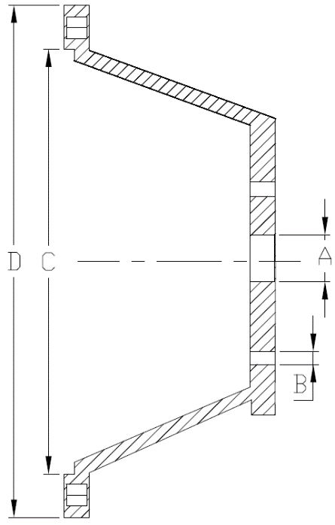

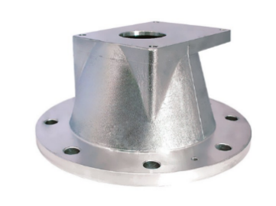

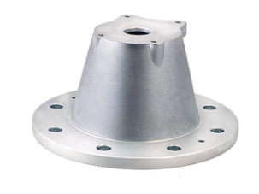

*All Dimensions are in mm.

|  |  |
| --- | --- |
| **MTK1* Series Bell - Housing** | |
| **Reference No** | **Electric Engine KW** | | **Technical Diameters** | | | |
| **A** | **B** | **C** | **D** |
| MTK116 | 0,25/0,37 | | 36,5 | M6 | 110 | 160 |
| MTK120 | 0,55/0,75/1/1,1/1,5 | | 36,5 | M6 | 130 | 200 |
| MTK125 | 2,2/3/3,7/4 | | 36,5 | M6 | 180 | 250 |
| MTK130 | 5,5/7,5/10 | | 36,5 | M6 | 230 | 300 |
| MTK135 | 11/15/18,5/22 | | 36,5 | M6 | 250 | 350 |

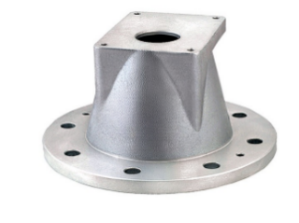

*All Dimensions are in mm.





|  |  |
| --- | --- |
| **MTK2* Series Bell - Housing** | |
| **Reference No** | **Electric Engine KW** | | **Technical Diameters** | | | |
| **A** | **B** | **C** | **D** |
| MTK220 | 0,55/0,75/1/1,1/1,5 | | 50,5 | M8 | 130 | 200 |
| MTK225 | 2,2/3/3,7/4 | | 50,5 | M8 | 180 | 250 |
| MTK230 | 5,5/7,5/10 | | 50,5 | M8 | 230 | 300 |
| MTK235 | 11/15/18,5/22 | | 50,5 | M8 | 250 | 350 |



*All Dimensions are in mm.

|  |  |  |
| --- | --- | --- |
| **MTKV* Series Bell - Housing** | | |
| **Reference No** | **Pump Diameter** | **Electric Engine KW** | | **Technical Diameters** | | | |
| **A** | **B** | **C** | **D** |
| MTKV20 | 80,5 82,7 | 0,55/0,75/1/1,1/1,5 | | 80,5 | 82,7 | 130 | 200 |
| MTKV25 | 80,5 82,7 | 2,2/3/3,7/4 | | 80,5 | 82,7 | 180 | 250 |
| MTKV30 | 80,5/82,7 100/101,8 | 5,5/7,5/10 | | 80,5/82,7 | 100-101,8 | 230 | 300 |
| MTKV35 | 80,5/82,7 100/101,8 | 11/15/18,5/22 | | 80,5/82,7 | 100/101,8 | 250 | 350 |

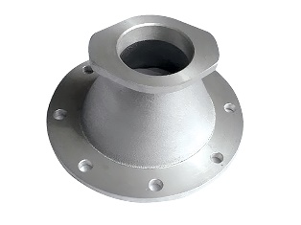

*All Dimensions are in mm.