|  |  |  |  |  |  |
| --- | --- | --- | --- | --- | --- |
| **LIGHT PUMP CONNECTORS** | |  | |  | |
| **Reference No** | **Center Dia.** | | **Description** | | **Thread Dia.** | |
| MTPAL3030 | 30x30 | | Straight Connector | | 3/8" | |
| MTPAL3040 | 30x40 | | Straight Connector | | 3/8" | |
| MTPAL3040-1 | 30x40 | | Straight Connector | | 1/2" | |
| MTPAL3535 | 35x35 | | Straight Connector | | 3/8" | |
| MTPAL4040 | 40x40 | | Straight Connector | | 1/2" | |
| MTPAL4848 | 48x48 | | Straight Connector | | 3/4" | |
| MTPAL5151 | 51x51 | | Straight Connector | | 3/4" | |
| MTPAL5656 | 56x56 | | Straight Connector | | 3/4" | |

***MTPA* Series Pump Connectors***

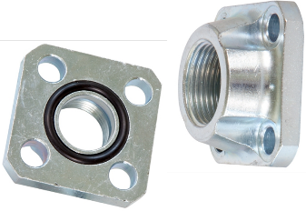

**It is supplied as set.**

|  |  |  |  |
| --- | --- | --- | --- |
| ***HEAVY PUMP CONNECTORS*** | |  |  |
| **Reference No** | ***Center Dia.*** | **Description** | **Thread Dia.** |
| MTPAH30 | 30 | Straight Connector | 3/8" |
| MTPAH35 | 35 | Straight Connector | 3/8" |
| MTPAH40 | 40 | Straight Connector | 1/2" |
| MTPAH48 | 48 | Straight Connector | 3/4" |
| MTPAH51 | 51 | Straight Connector | 3/4" |
| MTPAH56 | 56 | Straight Connector | 3/4" |

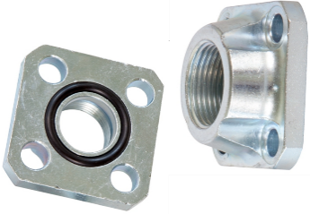

**It is supplied as single.**

|  |  |  |
| --- | --- | --- |
| **ELBOW PUMP CONNECTORS** |  |  |

|  |  |  |  |
| --- | --- | --- | --- |
| **Reference No** | ***Center Dia.*** | **Description** | **Thread Dia.** |
| MTPAE30 | 30 | Elbow Adapter | 3/8" |
| MTPAE30-1 | 30 | Elbow Adapter | 1/2" |
| MTPAE35 | 35 | Elbow Adapter | 3/8" |
| MTPAE35-1 | 35 | Elbow Adapter | 1/2" |
| MTPAE40 | 40 | Elbow Adapter | 1/2" |
| MTPAE40-1 | 40 | Elbow Adapter | 3/4" |
| MTPAE48 | 48 | Elbow Adapter | 3/4" |
| MTPAE48-1 | 48 | Elbow Adapter | 1" |
| MTPAE51 | 51 | Elbow Adapter | 3/4" |
| MTPAE51-1 | 51 | Elbow Adapter | 1" |
| MTPAE56 | 56 | Elbow Adapter | 3/4" |
| MTPAE56-1 | 56 | Elbow Adapter | 1" |

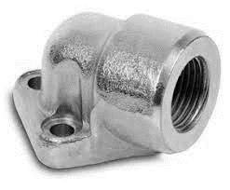

**There are 3 connection holes. It is supplied as single.**

***MTPA* Series Pump Connectors***

|  |
| --- |
| **ELBOW PUMP CONNECTORS** |

|  |  |  |  |
| --- | --- | --- | --- |
| **Reference No** | ***Center Dia.*** | **Description** | **Thread Dia.** |
| MTPAE35-40 | 35 | Elbow Adapter | 3/8" |
| MTPAE35-41 | 35 | Elbow Adapter | 1/2" |
| MTPAE40-40 | 40 | Elbow Adapter | 1/2" |
| MTPAE40-41 | 40 | Elbow Adapter | 3/4" |

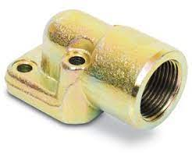

**. There are 4 connection holes. It is delivered as single.**